Instructions on Uploading Writing Samples to the
YSU Repository of Assessment Documents
You have been asked to upload a sample of your writing to help assess whether the University has been effective in teaching students how to use writing to communicate effectively. Evaluations of student writing will only be reported for groups of students; information about individual students will not be released. Please follow the instructions below to upload your document.
- Prepare the most recent copy of the paper that you have been asked to submit to ROAD from your particular major course.
  - Remove any information that would identify you or your instructor. Don’t forget to remove the header or footer if it contains identifying information.
  - Insert the description of your assignment into the beginning of the document. [This description has been provided for you digitally by your instructor]
  - Save your file as either a Microsoft Word document (a doc or docx file) or a pdf file. Include all of the following in a SINGLE file:
    - Instructor’s description of (or directions for) the assignment
    - Title Page (if needed, such as for APA style)
    - Abstract (if needed, such as for APA style)
    - Paper Body
    - Bibliography/References/Works Cited/Endnotes (as required per style guide)
- Upload the writing sample
  - Go to https://my.ysu.edu and log into MyYSU.
  - Click on the link Access My Student Information.
  - Click on the link Writing Repository.
  - Select the term the assignment was given (typically the current term), then click on the Submit button.
  - Select the class in which the assignment was given. If your instructor has indicated that the document will be used only for assessment of the major, click the Yes button. Click the Select Course button.
  - Click on the Browse button. A dialog box will appear that will allow you to identify the file to upload. Select the file and click on the Open button. After the dialog box closes, click on the Submit button.
You will receive a message indicating that the file was uploaded.
Notes:
- Only student accounts have the Access My Student Information link. Faculty cannot upload documents through their accounts.
- Departments are free to modify this document to better meet their specific circumstances. A version of this document with screen shots follows on the succeeding pages.
Instructions on Uploading Writing Samples to the
YSU Repository of Assessment Documents
You have been asked to upload a sample of your writing to help assess whether the University has been effective in teaching students how to use writing to communicate effectively. Evaluations of student writing will only be reported for groups of students; information about individual students will not be released. Please follow the instructions below to upload your document.
- Prepare the most recent copy of the paper that you have been asked to submit to ROAD from your particular major course.
  - Remove any information that would identify you or your instructor. Don’t forget to remove the header or footer if it contains identifying information.
  - Insert the description of your assignment into the beginning of the document. [This description has been provided for you digitally by your instructor]
  - Save your file as either a Microsoft Word document (a doc or docx file) or a pdf file. Include all of the following in a SINGLE file:
    - Instructor’s description of (or directions for) the assignment
    - Title Page (if needed, such as for APA style)
    - Abstract (if needed, such as for APA style)
    - Paper Body
    - Bibliography/References/Works Cited/Endnotes (as required per style guide)
- Upload the writing sample
  - Go to https://my.ysu.edu and log into MyYSU.
  - Click on the link Access My Student Information
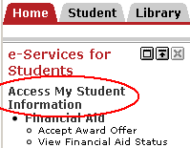

  - Click on the link Writing Repository.
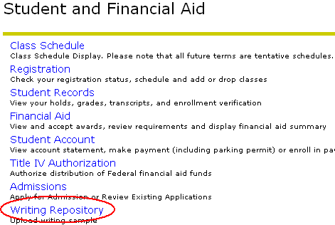
  - Select the term the assignment was given (Fall 2012), then click on the Submit button.

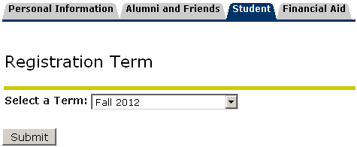
  - Select the course in which you wrote the paper that you are submitting. This document will not be used for assessment of the major, so leave the No button checked. Then click the Select Course button.
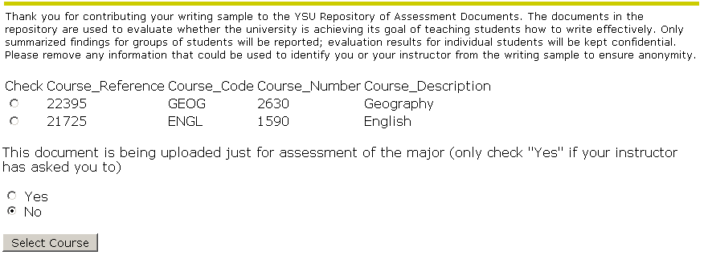
  - Click on the Browse button. A dialog box will appear that will allow you to identify the file to upload. Select the file and click on the Open button. After the dialog box closes, click on the Submit button.
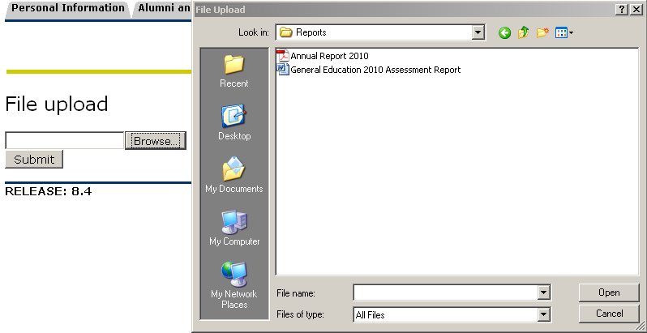
You will receive a message on the screen indicating that the file was uploaded.
Note:
- Departments are free to modify this document to better meet their specific circumstances.

